ASSIGMENT NO.2

Course: AT72.03 – Statistical Models and Design of Experiments

- A fair coin is tossed 5 times. What is the probability that exactly 2 heads are observed?
Ans. 0.313

- A student randomly guesses the answers to a five question true/false test. If there is a 50% chance of guessing correctly on each question

  - What is the probability that the student misses exactly 1 question?
  - What is the probability that the student misses no question?
Ans. 0.156 and 0.031

- On Saturdays, cars arrive at a repair shop at the rate of 6 cars per fifteen minute interval. Using the Poisson distribution,
  - Find the probability that five cars will arrive during the next fifteen minute interval
  - Find the probability that five cars will arrive during the next five minute interval
Ans. 0.1606 and 0.0361

- Suppose a committee of 3 people is to be selected from a group consisting of 4 men and 5 women.
  - What is the probability that all three people selected are men?
  - What is the probability that one man and two women are selected?
Ans. 0.05 and 0.48

- The distribution function of X is given by

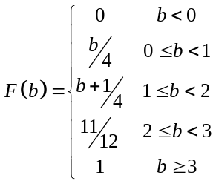

  - Find 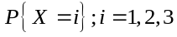
  - Find 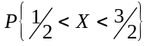

- The distribution function of X is given by

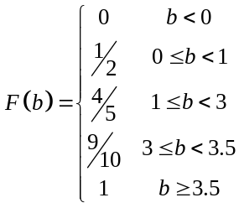
Find the probability mass function of X.

